Master 's Degree Thesis of Xi'an University of Science and Technology

ABSTRACT  
As basic measuring tools，mechanical calir'ers have been widely used in manufacture  
industry．But its difficult reading，low accuracy and single function carl not meet the need of  
modem manufacture．With the development of electronic technology it makes easier to  
integrate all functions of production into one chip，which Call reduce cost and volume of  
system．increase capability,and decrease power dissipation．The digital ealipers witll  
advantages of small volume，small output impedance，hi曲sensibility,、vide temperature  
range，low power dissipation，little parasitic capacitance will be used more widely．  
Firstly,displacement-measuring principle of digital calipers is analyzed and capacitive  
transducers model applied to data processing is presented、Ⅳit}l Verilog·A and simulated by  
Spectre．Secondly,logic circuits are designed to meet the demand of capacitive system，and  
three important parts of them are researched as follows：charge pump circuit is designed to  
reduce  
power dissipation．Demodulation circuit is designed to demodulate and magIlify the  
output signals of capacitive transducers．Phase discriminator is designed to distinguish the  
different phase between input signal and output signal of capacitive transducers．Meanwhile，  
logic circuits above are simulated and validated by Hspice．Thirdly,layout based on 3um  
CMOS Process is designed and checked．Finally,this novel chip witll high integrity,low  
power dissipation and mixed signal tapes out and is sold in the market．

# Overview of the development of detection technology and integrated circuits

## Status and development trend of detection technology

Today's era is the era of information technology, often in the field of information access and use as the center. In modern industrial life

Production, instrumentation, high degree of automation and information management in the process of modernization, has emerged a large number of computer-centric

Information processing and process control combined with the practical detection system. With the development of such a system, some advanced technology,

Such as information sensing technology, data processing technology and computer control technology is rapidly developing and constantly changing. Synthesize it

Development overview, mainly in the following aspects of development trends.

(1) integration and integration

Electronic measuring instruments, automated instruments, intelligent detection systems, data acquisition and control systems in the past belong to different

Of the subject areas, and their independent development. Due to the demand for production automation, so that they are close to each other in development

Can be covered with each other, the difference is reduced, embodied as a "information flow" integrated management and control system.

(2) multi-functional and intelligent

Intelligent instruments or systems can change with the external conditions, with the ability to determine the correct action. For example, intelligent

Detection instrument can change the measured parameters, the automatic selection of measurement programs, self-correction, self-test, self-diagnosis, also

Can be remote settings, status combinations, information storage, network connectivity, etc., in order to obtain the best test results. Such as the use of

Real-time dynamic modeling technology, online identification technology, according to the expert system knowledge base, decision-making control mode and control policy

Slightly, can achieve excellent control performance, can solve the conventional control is not easy to achieve the problem.

(3) systematic and standardized

Modern detection of the task, more related to the characteristics of the system. The so-called system refers to a number of mutual internal relations

The elements of the composition of a whole, by which to complete the specified function to achieve a specific goal. For example

Collection of detection and control with the front-end machine or instrument, it needs and production equipment, host, auxiliary machine integrated one, built

To form a distributed data acquisition system to accommodate the needs of open systems, complex projects and large systems.

want. In the systematic development of the system components also involves the standardization of the interface, modular and modular, so that shape

Into the general as a whole.

(4) instrument virtualization

With the rapid development of microelectronics technology and computer technology, detection technology and computer deep combination is caused

A new revolution in the field of instrumentation, a new instrumentation concept that leads to a new generation of instruments for a virtual instrument

Appear and come to practical. Virtual instrument VI (V'trtual Instrument) is with computer technology and modern measurement technology. The development of a new high-tech products, represents the development of today's new direction of the instrument. VI is using existing ones

Of the micro-computer, coupled with specially designed instrument hardware and special software to form the basic functions of both ordinary instruments,

There are general equipment does not have the special function of the new computer instrument system. The main work of vI is to put traditional instruments

The control panel ported to the ordinary computer, the use of computer resources, to achieve the relevant monitoring and control needs. Cost-effective,

Can be widely used in testing, research, production, military and other aspects of detection and control.

(5) network

Accessing a smart inspection and control system into a computer network will undoubtedly enhance its functionality and vitality. example

For example, a device engineer traveled in the field, suddenly received the factory phone, said that is monitoring a machine

There have been abnormal sound and vibration, need to be resolved. She opens the carry-on computer, via the internet with another city

Of the experts exchanged views, in 20 minutes to solve the problem. Therefore, the network is also a smart detection technology

Important development direction [1].

## Development of integrated circuits

Since the invention has been invented for more than 40 years, memory, microprocessors and other large-scale integrated circuits (Large

Scale Integrate circuits, LSI) applications have been 30 years of history. During this period, the integrated circuit continues

The rapid development of the formation of a new integrated circuit industry, the development of society has made a significant contribution. At present, as

Information technology is the main pillar of communications equipment and computers, in which the main hardware devices are integrated circuits. To the integrated circuit

The development of microelectronics technology for the logo is ubiquitous and has become the foundation of modern information technology.

In 1946, the world's first electronic computer was born in the United States Pennsylvania (Pennsylvania) University.

The computer, named ENIAC, consists of 18,000 tubes, 70,000 resistors, 10,000 capacitors and

6000 relay composition. Read-only memory (ROM) capacity of 16KbR, random memory (RAM) capacity for

1Kbit, the clock frequency is 100kHz. This computer is 30m long, wide 1m, high 3m, weight 30t, power consumption

of 174kW. Due to the life of the tube, the average time for this computer is only 2.5 hours.

In 1948, the electrical contact transistor came out, in 1949, the junction transistor came out, and by the junction of the transistor

The computer was put into the market in 1955.

In 1959, the world's first integrated circuit in the United States Texas Instruments (TI) and the United States Fairchild was born,

This integrated circuit only integrates four transistors. In 1962 the world appeared the first piece of integrated circuit official goods,

This indicates that the third generation of electronic devices have officially boarded the electronics arena. The invention of the integrated circuit greatly promoted the electronic design

Prepared for miniaturization and low power consumption. Compared with the use of a single tube and transistor, the use of integrated circuits can also be greatly reduced

The failure rate of low-cost electronic equipment makes it possible to manufacture larger electronic systems.

Since the birth of the integrated circuit in 1959, has experienced small-scale, medium scale, large-scale, large scale and even

Large-scale development process, as listed in Table 1.1. Has now entered the era of system integration or system-on-chip, as shown in Figure 1.1

, Various functional modules such as memory, digital circuits, analog circuits, and input / output interfaces

Circuits, etc. integrated in a chip. From the characteristics of the integrated circuit, the characteristics of the current commercial integrated circuit chip. From the feature size of the integrated circuit, the current commercial IC chip features a size of 0.15um-O. 18um, the future development trend is 0.045um ~ 0.10um, that is, integrated circuits have entered deep Asia

Micron process and ultra-deep sub-micron process era. Integrated circuit technology is rapidly toward a higher degree of integration, ultra-miniaturization,

High performance, high reliability of the direction of development.

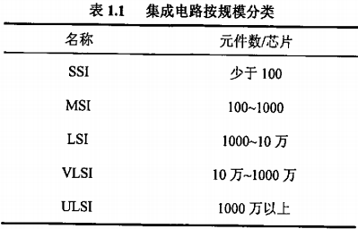

Over the past 40 years, the development of integrated circuits has been followed by one of the founders of Intel Corporation.

Moore's Law published in 1960, that is, the integration of integrated circuits doubled every three years. Is expected to integrate within the next 15 years

The development of the road still obeys the law.

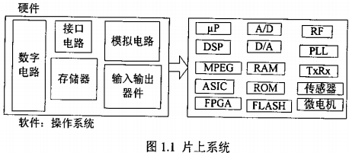

At present, the integrated circuit in two directions: First, in the development of micro-processing technology on the basis of the development of ultra-high

Speed, ultra-high integration of the circuit. Second, the rapid and comprehensive use has been achieved or mature technology, design skills

Surgery, packaging technology and testing technology to develop a variety of special-purpose integrated circuits [2].

# Present Situation and Development Trend of Capacitance Grating technology

For half a century, countries around the world are working to develop displacement sensors and digital measurement systems. So far,

Universally recognized has been widely used in the grid displacement measurement technology, in accordance with the order of origin is the sensor synchronizer,

Grating, grating, grid and grid. As the lithography, replication technology and microelectronics technology developed rapidly, grating, capacitive measurement

The amount of production costs of the system decreased significantly, and its technical indicators continue to increase in more than 90% of machine tools and measuring machines are

Grating, in the measuring instrument, measuring instrument more than 90% are capacitive gate.

At present, the domestic digital scale (or digital display device) mostly grating, magnetic gate and induction synchronizer. These devices

Have the advantages, but the cost is high, the structure is complex, the use environment and installation conditions are high, especially between the various parts of the connection difficult, vulnerable to interference, difficult to popularize and achieve the existing machine tool equipment in the application The Using capacitive sensing

Device can be a good solution to the problems of the digital display system, such digital display with a simple structure, the cost

Low, small size, low energy consumption, easy installation and installation, environmental adaptability, high resolution, wide dynamic range and so on.

In particular, the displacement part of the displacement sensor without power, a fundamental solution to the problem of difficult wiring. And therefore apply

Displacement of a variety of mechanical equipment in the digital display automatically [3].

## Status and development of domestic digital measuring tools

Previously China International Machine Tool Exhibition on the exhibition of domestic digital measuring products, showing the number of mechanical gauges in China Significant development process. China's measuring industry in the relevant electronics industry, research institutes, institutions of higher learning co-operation, After years of unremitting efforts, from the introduction, digestion, absorption, until the self-study and developed with independent intellectual property rights And patented advanced electronic sensor digital technology, mass production of electronic digital measuring tool series of products, has made remarkable achievement. Domestic digital measuring with a few years ago simple strip LCD digital display to the development of more complex surface LCD dynamic. The simulated image shows that the capacitive barrier resolution from 0.01mm development 0.001mm, the measurement accuracy and reliability are available

Significantly improved. Increased waterproof and dustproof performance (from IP54 to lP65, now up to IP67), by Strong domestic competitiveness of the market. China capacity grid digital caliper in recent years a large number of exports in the international market has been Occupies a pivotal position, is one of the best examples. According to China Machine Tool Industry Yearbook statistics show that in recent years, China's tool industry (including knives and measuring tools Measuring instrument manufacturing) has made great progress. Compared with 2000, industrial output value increased by 11.18%, sales output value increased by about 11.5%; industrial output in 2002 increased by 20.18% year on year, sales growth of 14.18%; 2003 The total industrial output value increased by 16.11%, sales output increased by 13.18%; the first half of 2004 and the same period in 2003

Compared to an increase in industrial output value of 22.19%, sales growth of 29.14%, strong economic growth momentum. As far as I

Statistics and forecast of the number of digital industry branch, the eleventh five period, the capacity of grid capacity and capacity of the grid capacity of the annual growth of demand

The rate will reach more than 20%, by 2010, sales will reach 8 to 1 billion yuan, the development prospects are very good. Guilin Guanglu Digital Measurement & Control Co., Ltd. as a domestic production and development of digital measuring tool leading enterprises, the development process is my

Country tool industry development of a few digital measurement of the best portrayal [4].

## Status and Development of Digital Industry in Foreign Countries

Foreign digital measuring tools developed rapidly, complete variety specifications, the system is more perfect, can be divided into the following categories, the number of

(Including digital height gauge, depth ruler, etc.), digital micrometer class, digital scale class and so on. Which capacitive grid

Digital display with the main manufacturers are: Switzerland TRIMOS and SYLVAC, Japan MITUTOYO (Mitutoyo). Capacity

The gate measurement system was introduced in 1973, and in 1974 TRIMOS was first applied to the altimeter. This new grid

The measurement system has been developed rapidly since 1980. The SYLVAC company, which specializes in the production of capacity grids in 1980,

Soon applied to digital calipers, dial gauge, altimeter and measuring instrument. MITUTOYO (Mitutoyo) is a well-known precision measuring instrument company, the company to provide the world with micrometers, calipers and other measurement tools. Its displacement measurement system

Are using the company's production of grating and capacitive gate. Table 1.2 shows the comparison of the number of digital calipers at home and abroad:

Table 1.2 Comparison of the number of digital calipers at home and abroad

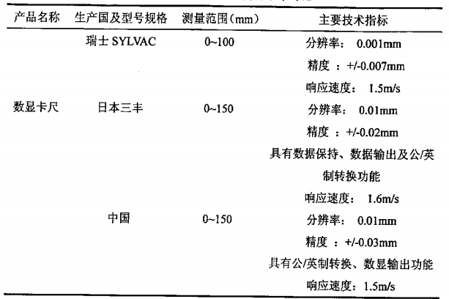

On the whole, both the product level, quality, or variety specifications, domestic digital measuring with foreign advanced water

Flat, there is still a big gap [5].

# The main content of this article and chapter arrangement

In this paper, according to the application of ASIC (ASIC) design method and design process, designed a highly integrated, low

Power consumption, digital - analog mixed digital caliper with control chip. Through the use of EDA software (Cadence) on the chip internal circuit

Function module is designed and simulated, and the chip layout design and physical verification are realized. The details are as follows:

The first chapter of the paper is the introduction, introduces the background of the research: the development of detection technology and integrated circuit.

And the development of digital industry at home and abroad. The second chapter is based on the analysis of the structure and working principle of the capacitive sensor

Based on the structure of the grid system, the structure and displacement measurement principle of the grid sensor are described in detail.

According to its working principle, the Verilog-A language is used to model and simulate the behavior of the capacitive gate sensor. Chapter 3, Introduction

(ASIC) design method, design flow and circuit simulation with the EDA software (Hspice), the use of special integrated circuit (ASIC)

The design and simulation of the circuit function module of the special chip of the grid - type digital caliper are described. Chapter 4 introduces the set

Circuit layout design method, and elaborated the layout design and physical verification of the special chip of the grid-type digital caliper. First

Chapter 5 describes the application of the design of the chip test. Chapter 6 is the summary and prospect of the full text.

# capacitive type Caliper Principle and Modeling and Simulation

Passenger gate sensor due to low production costs, low power consumption, simple structure, fast, therefore, in the measuring tool, measuring instrument Get more and more applications, which, capacitive grid-type digital caliper is the most successful example [6].

This chapter starts from the composition of the analysis and detection system, mainly introduces the composition of the grid-type digital caliper and the parts

Working principle, focusing on the analysis of the important components of digital caliper - capacitive sensor working principle, and its modeling and

simulation.

## The composition of the detection system

Detection technology has been applied to almost all industries, it is a comprehensive application of multidisciplinary knowledge, involving semiconductor technology,

Laser technology, fiber technology, voice control technology, remote sensing technology, automation technology, computer application technology, and mathematical

Statistics, cybernetics, information theory and other modern new technologies and new theories. The ultimate purpose of the detection system is from the measurement object

In order to achieve this purpose, a generalized detection system

Home, test device, data processing and recording device (Figure 2.1)

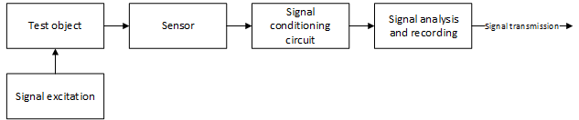

Figure 2.1: Detection system schematic

## Features of each component

(1) excitation signal

The excitation signal is generated by the excitation means, and the excitation means is used in order to keep the object under test in the predetermined state and

The relevant aspects of the internal links are fully displayed in order to facilitate the effective measurement. When the test work is desired to get the letter

Is not directly loaded into the detectable signal, it is necessary to stimulate the measured object, so that it can represent the relevant information and

Easy to detect.

(2) test object

The characteristics of the test object are given in the form of a signal, the measured signal is generally dynamic changes over time, that is,

So that when the static quantity that does not change with time is detected, it is usually checked by dynamic state due to the mixed interference noise

Measurement. Since the measured signal describes the characteristic information of the measured signal, and the structure of the signal itself, the selected test device

Have a significant impact, it should be familiar with and understand the basic characteristics of various signals and analysis methods.

(3) sensors

The sensor is the first part of the detection system, its main role is to perceive the measured non-power according to a certain law into a certain value output, usually the electrical signal. A wide range of sensors can detect almost all non-power. but

Because the sensor output of the many types of electrical signals, power is small, it is generally not directly to the electrical signal transmission to the follow-up letter

No. processing circuit or output components to go, must go through the signal conditioning.

(4) signal conditioning circuit

The role of signal conditioning circuit has two main aspects: First, the signal from the sensor to convert and enlarge,

So that it is more suitable for further processing and transmission, in most cases is a variety of electrical signals into voltage, current, frequency, etc.

A few few easy to measure the electrical signal, the output power can reach mW level; the second is to carry out signal processing, that is,

After conditioning the signal, the filter, demodulation, attenuation, computing, digital processing.

(5) signal analysis and recording

Signal processing circuit output of the measurement results is a true record of the measured signal, in order to show its change process,

To use oscilloscopes, screen displays, printers and other output devices. Modern detection system uses a computer and network technology

Surgery, the conditioning circuit output signal sent directly to the signal analysis set, on-line processing, has been in the engineering testing and

Industrial control has been widely used [7].

## Capacitive sensor works and structure of the form

The sensor is the necessary tool for information detection, is the production of automation, scientific testing, measurement accounting, monitoring and diagnosis

The essential link in the system, usually between the detection system and the object being measured between the interface, in the detection system

Of the input, its performance directly affects the entire detection system, the detection accuracy plays a major role. Commonly used sensor

Types are: resistive sensors, capacitive sensors, inductive sensors, photoelectric sensors, intelligent sensors

Wait. This section will briefly introduce the working principle and structure of the capacitive sensor, as a step-by-step analysis of the grid sensor Foundation.

Capacitive sensor is the measured physical quantity into a capacitance change of a conversion device, in fact, is a Capacitors with variable parameters. Capacitive sensors are widely used in displacement, angle, vibration, speed, level, pressure,

Component analysis, media properties and other aspects of the measurement. But the capacitive sensor leakage resistance and non-linear and other shortcomings also give it The application has brought some limitations. With the development of electronic technology, especially the application of integrated circuits, these shortcomings also

Has been overcome, thus further promoting the application of capacitive sensors.

The basic principle of capacitive sensors can be used A.

# a parallel plate capacitor as shown will be explained.

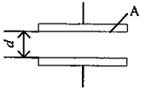

Figure 2.2 Schematic diagram of capacitive sensor operation

Set the poles The effective area covered by the plates is between A and the plates

Distance d, vacuum dielectric constant e0, plate between the intermediary

The relative dielectric constant is e, and the air medium e = 1.

Under the condition that the edge effect of the plate is neglected, A

Can write parallel plate capacitor capacitance expression is:



From (2.1) can be seen, e, d, A three parameters have a direct impact on the size of the capacitance C. If guaranteed

Hold the two processes unchanged, and make another parameter change, the capacitance will change. If the change of this

There is a certain function transition between the parameter and the measured value, then the measured change can be made directly by the capacitance

Changes of the capacitive sensor in the structure can be divided into three types, that is, change the plate area of ​​the change

Area sensor: change the distance between the plate gap sensor: change the dielectric constant of the variable dielectric constant sensor

Device.

The following three kinds of capacitive sensor operating characteristics of the analysis.

(1) variable area capacitance sensor

Variable area capacitance sensor cable displacement type and angular displacement type two. Line displacement type capacitive sensor can be divided into

Plane line displacement and cylindrical line displacement of two (as shown in Figure 2.3).

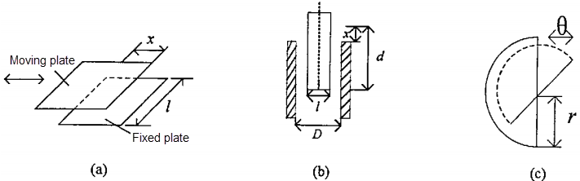

Figure 2.3 Displacement type capacitive sensor (a) Flat type (b) Cylindrical (c) angular displacement type

Figure 2.3 (a) plane line displacement type sensor, the capacitance is:



Sensitivity is

C:\Users\KLIJN\AppData\Local\Temp\SNAGHTML4b442a6.PNG

Figure 2.3 (b) cylindrical line displacement device, the capacity of:



Sensitivity is

C:\Users\KLIJN\AppData\Local\Temp\SNAGHTML4b69d01.PNG

Figure 2.3 (c) angular displacement type sensor, the capacitance is:



among them, 

Sensitivity is:

C:\Users\KLIJN\AppData\Local\Temp\SNAGHTML4b9e825.PNG

In the above formulas (2.2) to (2.7), the width of the capacitor plate is.

The output of the variable area capacitance sensor is linear with the input, but the sensitivity is lower than that of the variable gap sensor,

Suitable for larger line displacement and angular displacement measurements.

(2) variable gap capacitance sensor

Figure 2.4 shows the structure of a variable gap capacitance sensor. In the figure, l is the fixed plate and 2 is the movable pole

Plate, the displacement is caused by changes in the measured, when the movable plate moving distance X, the capacitance can be changed to (formula

2.8)

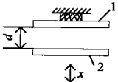

2.4: Variable gap type sensor (1 = a fixed plate 2 = movable plate)

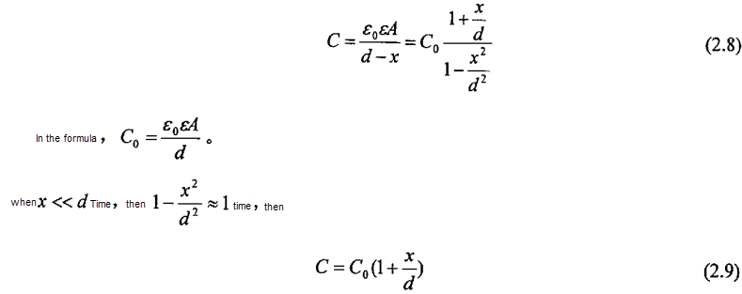

Equation (2.8) shows that the capacitance c and X are not linearly related, only when x << d, can be considered as

Similar to the linear relationship, so this type of sensor is generally used to measure the amount of small displacement, usually 0.01um

To a few millimeters of wire displacement. At the same time, variable gap capacitance sensor to improve the sensitivity, should reduce the initial gap d.

But when d is too small, it is easy to cause capacitive sensor breakdown, which increases the difficulty of TJJnz. To this end, generally in the

Plate between the placement of mica, plastic film dielectric high dielectric constant to improve this situation. In practical applications, in order to improve

Sensitivity, reduce the non-linear, variable-gap capacitor commonly used differential structure.

(3) variable dielectric constant capacitance sensor

The structure of the variable dielectric constant capacitance sensor is shown in Figure 2.5. Most of this type of sensor is used

Measuring the thickness of the dielectric, displacement, liquid level, liquid volume, but also according to the inter-electrode medium node constant with temperature, humidity,

Change the capacity to measure the temperature, humidity, capacity and other equal. The figure shows the insertion depth of the measuring medium

Capacitance can be expressed as C = CA + CB.

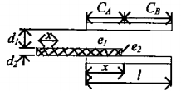

2.5 variable dielectric constant capacitance sensor

among them:

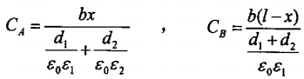

There is no capacity between the plates when there is no e2 medium:



When the e2 medium is inserted into the bipolar plate, the capacity is

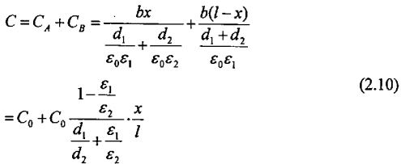

Equation (2.10) shows that the capacitance C is linearly related to the displacement X.[7][8]

## 2.1.3 Basic characteristics of capacitive sensors

From the previous analysis we can see that the capacitive sensor is actually a kind of variable parameters of the capacitor

(1) If a voltage signal V is added to one of the plates of the capacitor, it will be on the other Generate the induced charge Q, and



Where V is the voltage value and C is the capacitance of the capacitor.

(2) the potential difference between the two plates of the capacitor is kept "inert", that is, if a voltage signal is suddenly loaded on one of the plates of the capacitor, the same voltage signal is necessarily induced on the other plate to Keep the plates

The original potential difference between the same. According to this feature, if a capacitor is loaded on a plate with a periodically changing carrier

(Excitation signal), then in the other plate must produce with the excitation signal has the same cycle of the induction signal,

The strength of the induction signal, according to (2.1) and (2.11) should be:

C:\Users\KLIJN\AppData\Local\Temp\SNAGHTML5182563.PNG

Where V is the excitation signal voltage.

Understand the structure of the capacitive sensor, working principle and characteristics, on this basis, the following will be further analysis of capacity

The structure of the gate system and the working principle of each part.

# The structure of the grid system and the working principle of each part

The capacitive grid caliper is a typical capacitive system, which consists of a capacitive gate sensor, which includes the following

Several parts: capacitive gate sensor, displacement device (mechanical part), signal and data processing (ie measurement circuit) and other groups

Into part. It can be seen that the grid system is a mechanical and electrical integration system. This section focuses on capacitive sensors and how its displacement measurement circuit works.

## 2.2.1 Structure and displacement measurement principle of capacitive gate sensor

The capacitive gate sensor is a capacitive digital sensor that can measure large displacements based on variable working principle.

It is digital displacement sensor, such as grating, induction synchronizer, etc., has the following advantages: Small size, structure

Simple, high resolution and accuracy, fast measurement, low power consumption, low cost, low demand for the use of the environment, because

This is an important place in the electronic measurement technology, widely used in digital calipers, dial indicator, measuring instrument, high

Measuring instrument and coordinate measuring machine and other digital measurement system. With the continuous development of electronic technology, especially the integrated circuit should be

So that the capacitive displacement sensor will be more widely used. In the whole measurement system, its main role is to machine

The amount of shift is converted into the amount of phase change of the electrical signal, and then sent to the measurement circuit for data processing.

(1) the structure of the capacitive sensor

According to the structure, capacitive grid sensor can be divided into linear, round, cylindrical three categories. Which is linear and cylindrical

The capacitive gate sensor is used for the measurement of linear displacement, and the circular capacitive gate sensor is used for the measurement of angular displacement. As used herein

Is a linear capacitive gate sensor, its structure shown in Figure 2.6, we can see that the structure of the capacitive sensor is very similar to the flat

Line plate capacitor, which is arranged by a set of grid-like structure of the parallel plate capacitor in parallel, including the dynamic grid plate A

And the fixed gate plate B two parts. The movable grid plate is composed of emitter and receiver poles, and the emitter includes 48

Small emitter, divided into 6 groups, each group has 8 small emitters. The width of the small emitter pole is w, every 8 small

The width of the emitter is a pitch S, ie S = 8 w; its size is related to the resolution of the sensor. Receive extremely

A long conductive bar, below the emitters has a length of 5*S (pitch), and the middle of the five groups corresponding to the emitter, that is, before and after

Each of the four small emitters, which is to eliminate the edge effect. The fixed grid is shown as shown in the figure for the dynamic grid plate

Is the epoxy copper plate corrosion on the width of S / 2, the interval of S / 2 and other parts of the insulation of the small rectangular box, the surface paste insulation protective layer, these small grid called the reflector, the other connected Partially shielded ground. Each of the moving grid plates

There are four small emitters in the emitter that are facing the reflector of the fixed grid, and the other four are on the shield of the fixed grid,

No effect. It can be seen that the capacitive gate sensor is composed of a plurality of variable capacitors.

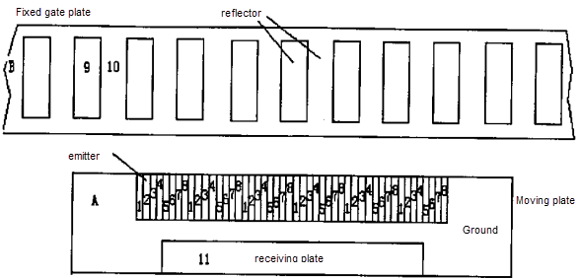

Figure 2.6 Structure of the grid sensor

(2) Displacement measurement principle of capacitive sensor

From the basic characteristics of the parallel plate capacitor described above, in the case of a single parallel plate capacitor, if the capacitor

A plate with a time-varying voltage signal, then in the other to the plate must be induced to produce the same week

Period of the signal changes, this signal cycle can only change with

Time-dependent; then for capacitive sensors, that is, multiple groups

Parallel board capacitors connected to the situation, such as structural diagram

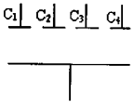

Figure 2.7 Schematic diagram of a simple structure of a capacitive gate sensor

Figure 2.7 shows.

If the periodic signal changes over time, through the electronic circuit control, at the same moment with a different phase distribution,

Are respectively loaded on the respective gate electrodes of the grid-like capacitors arranged on the other common plate, and at any instant

The inductive signal will have the same phase distribution as the momentarily loaded excitation signal. It is worth noting that: one, order

Arrangement, has been the phase distribution and space (here refers to the distance) linked; Second, said the induction signal and the incentive letter

, The precondition is to assume that the capacitor bipolar plate is relatively stationary, then, if the capacitor bipolar plate occurs relatively

Move, even if the excitation signal does not change, with the space changes, the excitation signal has a different phase distribution, induction letter

Will also be with the relative position of the two plates and constantly changing; Third, the excitation signal itself is time-varying

The periodic signal so that the excitation signal has a different phase at the same gate at the same moment, at the same position on the gate

Different moments have different phases, and the movement of the plate is different from the spatial position, the movement process takes time,

So the displacement of the plate, the sensor signal changes are extremely complex, but also the traditional method can not be observed and measured,

Here, the role of microelectronics technology to achieve the most vividly play, it on the one hand at any time to control the excitation signal

When the order to send, and every moment of the excitation signal as a standard, on the other hand, and at any time to receive the induction signal and

When compared with the standard signal to determine the relative displacement of the plate, and display it to the observer, which is the use of capacitive sensors to determine the basic principle of displacement.

The equivalent circuit of the capacitance formed between the grid and the grid of the grid is shown in Figure 2.8. Let C1(x), C2(x), C3(x)… …C8(x) be the equivalent plate of 48 plates on the movable grid and the corresponding plate Capacitance, which is the displacement x

, Assuming that the capacitance between the small emitter plate and the reflector plate is fully covered is C0, and each small emitter

The width of the plate is W, it can be seen from Figure 2.8 that when 0 ≤ x ≤ w, C8(x)=C0 (x/w), C1(x)=C2(x)=C3(x)=C0, C4(x)=C0(1-x/w), C5(x)=0, C6(x)=0, C7(x)=0. It can be concluded that in the whole range between the two plates there is a variation of capacitance with displacement. From the equivalent circuit diagram figure 2.8 the relationship of this displacement x and phase shift ɸ(x) can be derived. ɸ(x) is the phase shift of the output signal of the sensor relative to a certain drive signal.

C:\Users\KLIJN\Desktop\Translation files\equivalent circuit.tif

Figure 2.8 Capacitive circuit of the grid sensor

In the figure: Cfg: The capacitance formed between the plates on the grid and the ground;

Cfr: The capacitance formed between the receiving plate on the movable grid and the

corresponding plate on the grid;

Crg: The capacity of the receiving plate on the movable grid and the "ground"

(shielding plate);

As can be seen from Figure 2.8, when x is any value, there are always ~ part of the 48 pole plates on the movable grid to form a capacitor with "ground" (shield), and the corresponding input signal source is directly connected to " , The output signal of the sensor does not affect, but in order to derive the ji (x) with the displacement x continuous change of the unified formula, in the derivation does not consider these plates on the "ground" to form a capacitor, and still treat them as a fixed gate Board to form a capacitor, but at this time their capacitance is zero. Since these capacitances are zero, the impedance is infinite. The corresponding signal source all fall on these capacitors, the same, the sensor output signal has no effect.

If the transmission voltage v1-v8 is applied to each emitter plate of the capacitive sensor is 8-channel frequency, the amplitude is the same and the sinusoidal alternating voltage of phase difference between adjacent small plates is pi / 4, then on the reflector There is voltage Vf, there is at the receiving pole Voltage Vr.

Application of AC circuit theory and Kirchhoff current law to the ideal circuit of Figure 2.8 is as follows:

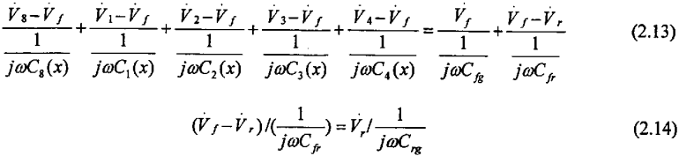

If V0 is used to denote the amplitude of each emitter voltage and take the phase of the first signal in the 8-channel signal as the reference value,

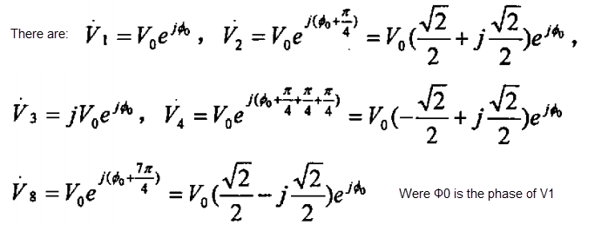

(2.13) and (2.14) are obtained by substituting the above quantities and the values of Ci (x) (i = 1, 2, ...,8)

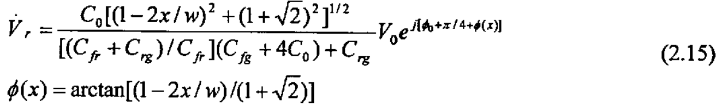

It can be seen that the output voltage of the capacitive gate sensor is the same sinusoidal voltage as the frequency and the amplitude of the emission. Its amplitude changes in a very small range and can be approximated as a constant, and the phase is higher than Vr before π / 4 + ɸ(x) , The phase shift ɸ(x) can be measured using a phase-finding measurement circuit to obtain the relative displacement x, which is a phase-tracking type displacement sensor which is insensitive to the amplitude of the input signal , So it has a good anti-interference ability.

It can be verified that there is a ɸ(0)-ɸ(w)=45° phase difference when the displacement equals the width of one emitter plate. It should also be noted that equation (2.14) only holds when 0 ≤ X ≤ w, and the phase combination corresponds to the position, otherwise equation (2.15) does not hold.

When -w ≤ x ≤ 0 or w ≤ x ≤ 2 w, the phase combination corresponds to the sequential forward or backward movement of pi / 4, then the equation (2.15) is still true with respect to the next 0 ≤ x ≤ w In the whole range on the type (2.15) are set up [9].

(3) The basic parameters of the capacitive sensor According to the analysis of the principle of the operation of the capacitive sensor, the relative displacement of the capacitor plate and the induction signal relative to the excitation signal changes in the quantitative corresponding to the following parameters must be determined:

① the period of the excitation signal. In this paper, the parameter T = 512, the value of which (also known as the clock pulse period) by the selected oscillator frequency 'f' decision, the system selected oscillator frequency f = 185.185KHz,

Thus ɸ = 1 / f = 5.4us, T = 512 ɸ, = 2.7648ms.

② excitation signal a cycle in the spatial distribution of the width occupied (also known as gate pitch) W, the system selected W = 5.08mm

On the other hand, when the received sensing signal changes in a period compared to the excitation signal.

It can be judged that the relative displacement of the bipolar plate is a pitch, that is, a displacement of 5.08 mm occurs,

The period shift amount ΔT is recorded, the displacement amount is obtained, that is, S = W × ΔT.

③ minimum resolution. The above equation is in the period T, the displacement change ΔT caused by the determination of the displacement, and the variation of each cycle represents the displacement of 5.08 mm, so that the measurement is too rough, but as described above, The minimum time unit is ɸ, and each cycle T = 512 ɸ, in the periodic signal, according to each ɸ represents a phase,

The entire signal period is decomposed into 512 phases, and the displacement distance ΔS corresponding to each phase change is naturally:

ΔS = W / 512 = (5.08 / 512) mm = 0.009921875mm ≈ 0.01mm

Or ΔS = 0.2 / 512inch = 0.000390625inch. Therefore, the minimum resolution of the digital caliper designed in this paper is 0.01mm.

④ dynamic gate (excitation pole) gate width WE selected. Taking into account the actual possibility of grid-like electrode processing, the influence of the edge effect of the gate electrode and the factors of circuit design, the system will be a cycle of the signal per 64 phase for a group,

Respectively, at the same time on the eight excitation electrode grid, so each excitation pole grid width is

WE = W / 8 = 0.635mm = 0.025inch, note that the spacing between the bars is included here.

⑤ fixed gate (sensing pole) gate width WK: the system of each sensor pole corresponding to four excitation pole width, therefore,

Wk = 4xWE = 2.54mm = 0.1inch

⑥ Calculation of maximum measurement speed Vmax and effect of oscillation frequency: Since the minimum resolution is a phase change, In a cycle time T, can only distinguish between 512 pulse equivalent, so the fastest measurement speed is:

Vmax = (512 · ΔS) / T = 1837.384259 mm / s

## 2.2.2 working principle of measuring circuit (integrated circuit)

As described above, the function of the capacitive gate sensor is to convert the amount of mechanical displacement into the amount of electrical phase change.

Measurement circuit, is the capacitive grid caliper implementation of the measurement of the heart, the use of modern microelectronics technology, all lines were

Integrated into a dedicated large scale integrated circuit. In a tiny silicon chip, the production of nearly 10,000 transistors, resistors, electricity

And the connection between the composition of the system required to work a variety of circuits, in fact, is a microcomputer in control

The system of the grid system. Its main role is: to the capacitive sensor to provide the required excitation signal, and with the same time

When receiving the induction signal, and through the phase-shaped circuit to measure the excitation signal and the induction signal phase difference, and then after a

Series of transformation and processing, and ultimately the mechanical displacement of the digital signal through the LCD screen display to the observer.

## 2.3.1 Simulation Hardware Description Language Verilog. A's characteristics and behavioral structure

Verilog-A is a high-level modular hardware description language, which uses the form of modules to describe the simulation system

And its subsystems. Its description of the analog circuit can be divided into two types, namely, behavior description and structural description

Described. Behavior description refers to the use of some mathematical expression or transfer function to describe the behavior of the target circuit, behavioral model can

Mapped to a netlist, the netlist model includes the model name, parameters, etc. of the behavior model, whose ports correspond to the port of the behavior model,

Table 2.1 shows the structure of the Vefilog-A behavior model; the structural description is the use of the various sub-modules in the system

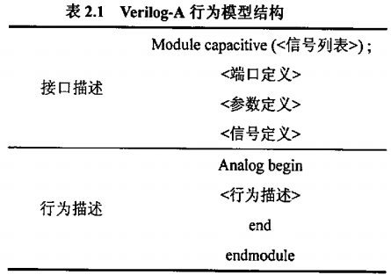

The connection between the module and the submodule is described, which can be understood as a description of the system block diagram. complete

The structure description also includes the definition of the signal, the definition of the port and the definition of the basic parameters

In order to facilitate the optimization of analog system performance and physical implementation between the design, Verilog-A provides a multi-layer

Sub-behavior and structure models and a variety of behavioral module description methods, including finite exponential generator limexp (), integral production

The generator idt (), the differential generator ddt () and the delay generator delay (), etc., to describe the analog circuit behavior module

function. Through the different functions of the set and combination, you can define the analog circuit modules, such as a variety of operational amplifiers,

Bandgap reference source, vehicle analog phase locked loop (APLL), voltage controlled oscillator (VCO), rectifier circuit, MOS capacitor, open

Off capacitor filter, digital-to-analog converter (DAC) and analog-to-digital converter (ADC), and then designed for SOC

Design of Analog Circuit IP Core Behavior Model. The Verilog-A behavior model of the analog IP core is then integrated into Specter

And other mixed-signal simulation environment, you can quickly achieve SOC design, and to ensure the seamless connection between IP.

Using Verilog-A language for behavior modeling, one can at the system level to optimize the design of the entire circuit:

Second, because the sub-module is a direct description of the behavior, do not need to take into account the transistor level, so in the simulation process,

Greatly reducing the amount of computing, saving simulation time, improve the accuracy of [12].

## 2.3.2 Modeling and simulation of capacitive sensor based on Verilog-A language

(1) Verilog-A model of capacitive sensor

From the above analysis of the working principle of the capacitive sensor, we can see that the variation of C1 (x), ..., C8 (x)

Function is described in Equation (2.16), where W = 0.635mm, C­0 = 0.116E-12.

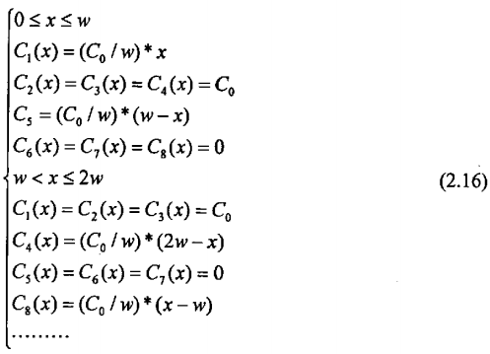

According to Figure 2.8, the unit equivalent structure of the capacitive sensor is shown in Fig. 2.9.

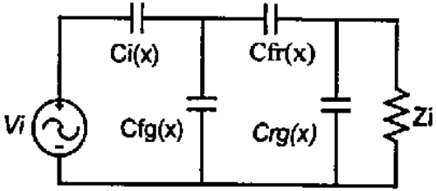

Figure 2.9 Equivalent model of the capacitive sensor unit

This model is based on the differential current relationship between the current flowing through the capacitor and the voltage across the capacitor, see equation (2.17).

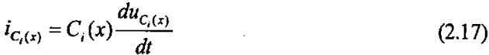

According to (2.16), (2.17), and Figure 2.8, Figure 2.9, using the Vefilog-A language for the capacitive sensor

Structure and behavior modeling. According to the working principle of the capacitive gate sensor, the capacitive sensor has eight input excitation signals

Port and an output signal port. In order to verify the performance of the capacitive sensor output signal with the displacement of the law,

The sensor is modeled with a pulse input port to simulate the displacement behavior. The Verilog-A model of the capacitive sensor is as follows

under:

／／VerilogA for wyy,sensor,vefilog-a  
’include“constants．ht’  
’include”discipline．h”  
module sensor(L1，L2，L3，L4，L5，L6，L7，L8，clk,out)；  
input L1，L2，L3，L4，L5，L6，L7，L8；//8 excitation signal input ports, ie the emitter of the capacitive gate sensor   
input clk； //Pulse input port  
electrical L1，L2，L3，L4，L5，L6，L7，L8，clk；  
output out； //output port  
electrical  
out；  
electrical L9； //reflector of the capacitive sensor  
parameter real W=0.635E-3；  
parameter real C020．116E一12；  
parameter real C911=i．337E一12，C910=6．66E一12；  
parameter real ZR=4E6；  
parameter real scale=0．2：  
real X，X1，X2，X3，X4，X5，X6；  
real C1，C2，C3，C4，C5，C6，C7，C8；  
analog begin  
@(initial_step)begin  
X=0：C1=0；C2=0；C3=0；C4=0；  
C5=0；C6=0；C7=0；C8=0；  
end  
@(cross(V(clk)一1．5，+1，0．01n，clk．potential．abst01))begin  
X=X+scale+W：  
if(X>9+W)X=O；  
if(()(>20)&&Ⅸ<-、Ⅳ))begin

Cl=(CO／W)*X：C2=CO；C3=CO；C4=CO；  
C5=(C0／W)*(W-X)；C6=0；C7=0；C8=0；  
end else if((x>w)&&(X<=2*W begin  
C1=C0；C2=C0；C3=CO；C4=(C0／W)+陀‘W-X)；  
C5=0；C6=0；C7=0；C8=(C0／W)*(X-W)；  
end else if((X>2*W)&&(X<=3*w))begin  
C1=C0；C2=C0；C3=(C0/W)*(3*W-X)；C4=O；  
C5=0；C6=0；C7=(Com3+Cx-2+聊；C8=C0；

:

:

:

end else$strobe(”beyong the range”)；  
end

// Structure of the capacitive gate sensor

I(L1，L9)<+C1+ddt(V(L1，L9))；  
I(L2，L9)<+C2+ddt(V(L2，L9))；  
I(L3，L9)<+C3+ddtfV(L3，L9))；  
i(L4，L9)<+C4‘ddt(V(L4，L9))；  
I(L5，L9)<4-C5+ddt(V(L5，L9))；  
I(L6，L9)<+C6+ddt(V(L6，L9))；  
I(L7，L9)(+C7+ddt(V(L7，L9))；  
I(L8，L9)<+C8+ddt(V(L8，L9))；  
I(L9)<+C910+ddtV(L9)：  
i(out，Lg)<+(I(L1，L9)+I(L2，L9)+I(L3，L9)+I(L4，L9)+I(L5，L9)+I(L6，L9)+I(L7，L9)+  
I(L8，L9))一ILL9)；  
V(out)<4-5+I(out，L9)+ZR；  
end  
// Behavior of the capacitive gate sensor  
endmodule

(2) simulation results

The Verilog-A model of the capacitive sensor was used in a simulation environment using Cadence Spectre

Simulator for simulation. In order to facilitate observation and analysis of the relationship between phase and displacement, simulation scale value of 1, which

, The rising edge of each pulse (ie, the simulated displacement signal) will produce a plate width W displacement, (2.15) shows that the phase will be corresponding to a change of 45°. In order to facilitate observation, simulation to the sensor input 8 adjacent phase difference of 45° sinusoidal excitation signal, and four clk pulse signal. The simulation results are shown in Figure 2.10:

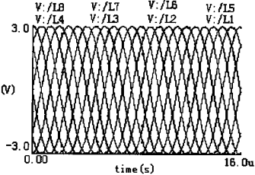

(A) 8 excitation signals

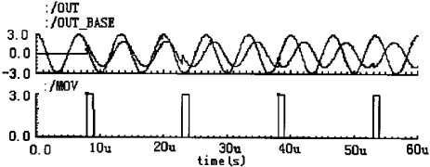

(B) phase comparison results

Figure 2.10 Verification of the Verilog-A model of the capacitive gate sensor

It can be seen that after four consecutive displacement analog pulses, the capacitive gate sensor output signal out and the reference signal

Out-base compared to the phase difference of 180. , The results fully verify the correctness of the formula (2.15), but also said

Understand the correctness of the model. The model can be applied directly to the verification of the entire grid measurement system

Verification provides a new approach, while also saving time.

# 2.4 Summary

In this chapter, the principle of displacement measurement using capacitive sensor is analyzed and analyzed according to its theoretical analysis.

The modular hardware description language-verilog-A models its behavior while passing the Cadence Specter simulator

The correctness of the model is proved and verified. The model can be directly used in engineering practice in the system validation, structure

Simple, fast simulation, high efficiency, which can greatly save the time of product development.

# 3 capacitive type digital calipers ASIC Design

# 3.1 Overview

Capacitive grid-type digital caliper special chip, using a modern microelectronics technology, is a novel highly integrated, low power

Consumption, digital-analog mixed-use integrated circuit (ASIc) chip. The chip is a capacitive system that performs the measurement of the heart. It is real

The main function is: on the one hand, to provide the capacitive sensor required excitation signal, and the moment of the excitation signal

As a benchmark; on the other hand, at any time to receive the induction signal and timely comparison with the reference signal to determine the plate

The amount of relative displacement that occurs, and display it to the observer.

The main contents of this chapter are as follows: Firstly, the relevant theoretical knowledge of integrated circuit design is introduced. Then,

Chip functional requirements, the overall structure of the system design, division of the system module, the sub-module circuit design,

And its sub-module circuit in the Hspice simulator for simulation verification.

# 3.2 integrated circuit design technology

The rapid development of modern electronic product performance thanks to the development of manufacturing technology and electronic design technology, the former to

Micro-processing technology as the representative, has developed into deep sub-micron stage, in a chip can be integrated millions or even tens of millions

Only the transistor is the core of the electronic design automation EDA (Electronics DesignAutomation) technology.

EDA technology is in the advanced computer work platform developed a set of electronic system automation design software workers

With It is mainly able to assist in three aspects of the design work: IC design, electronic circuit design and PCB (Printed Circuit

Design. The following will briefly describe the relevant integrated circuit design technology and the methods used in this article [13].

## 3.2.1 Design Method of Application Specific Integrated Circuit (ASIC)

Application specific integrated circuits (ASICs) can usually be divided into full custom integrated circuits (Full Custom IC), semi-custom set

A semi-custom IC and a programmable logic circuit. Semi-custom integrated circuits can be divided into standard cell circuits

(Cell-Based IC) and gate array (GateArray) two categories. The corresponding circuit design can be divided into full custom design method,

Semi-custom design method and programmable logic device (PLD) design method, the chip design is in accordance with the full custom design side

Law carried out.

Full custom ASIC circuit is designed for a user design, manufacture of integrated circuits. Full customization integrated circuit

In the design did not use the pre-compiled or designed good unit, from the circuit diagram input to complete the logical verification,

Layout generation, mask (MASK) manufacturing to chip production of a full set of integration process. Due to the use of artificial methods in the crystal

At the level of the system, the performance of each unit, the optimal design of the area, the integration of the unit area than other types of ASIC

High circuit, reflecting the high integration, high chip utilization characteristics. Full custom ASIC for large quantities of mature production

Production, but the design cost is high and the cycle is long. In order to shorten the design and production cycle, in the design process can be used

CAD way, the production process using a mature semiconductor integrated circuit technology.

Unlike full custom ASICs, most of the semi-custom circuit design and manufacturing process is not for a specific use

Households. Semi-custom gate array (GateArray) design method and standard cell (Cell-BasedIC) design method is a constraint

The main purpose of the design method is to simplify the design to sacrifice the performance of the chip at the expense of shortening the development time.

Gate array design method refers to the pre-production of the gate array on the bus to complete the ASIC to complete a design side

law. In the door array on the mother of a series of pre-production process, you can continue to steam so far, for not

With the same user circuit, simply complete the aluminum lead design and manufacture that can achieve the required ASIC. The advantage is the development week

Short and small variety of small batch production costs lower.

Standard cell design method refers to the design of a number of macro units and stored in the system library, when the custom circuit

Call, and layout and routing. The standard unit design method can not be pre-processed before the customized product process line,

So a full set of masks is required. Functional elements in a standard cell library typically include: basic logic gates and buffers: triggers

And shift registers such as SSI, MSI circuits; RAM, ROM, PLA, ALU 8-bit and 16-bit microprocessors

LSI circuit, and continue to enrich such as operational amplifiers, A / D, D, A converter analog circuits. Currently with CPU as

Core, including a variety of peripheral circuits ASIC microcontrollers are rapidly developing.

Standard unit design method has the following characteristics: (1) all units are optimized design, chip layout than the door array tight

So that it can improve circuit performance and reduce the chip area: (2) the layout of the unit is fixed, in the custom only unit layout

And the unit wiring, so the design time is much less than the whole custom; (3) vh need a full set of mask, process manufacturing time

And the cost is the same as that of the whole customization.

The programmable logic device PLD (Programmable Logic Device) can be compiled by the user at the job site

A digital integrated circuit that implements the required logic functions. Is an important branch of ASIC, can also be considered

Is the manufacturer as a general-purpose device production semi-custom circuit. Programmable logic device (PLD) design method is used

The internal logical structure of the PLD implements the desired Boolean expression or register function, obtaining the required logic functions,

Chip function design method. PLD will mask ASICs with high integration characteristics and programmable logic device design and production

Convenient features combined, especially suitable for sample development or small batch product development, complete the layout design, in the

The laboratory can burn their own chips, without the need for IC manufacturers to participate, to speed up time to market. When the market is expanding

, It can be easily transferred by the mask ASIC to achieve, greatly reduce the development of Fengkui [14].

## 3.2.2 ASIC design flow

Integrated circuit design includes logic (or functional) design, circuit design, layout design and process design. Its design

The process is summarized as follows:

(1) System Specification (System Specification)

Including system function, performance, physical size, design pattern, manufacturing process, design cycle, design costs.

(2) according to functional requirements for system design

The system function of the implementation of the program designed, mainly to consider the behavior of the system characteristics, usually given the modules

Between the data flow chart.

(3) divided into subsystems (functional blocks) for logical design

This step is the first step in the system function. And then the logical design of the various sub-modules, designers usually use

Text, schematics, or logic diagrams.

(4) by the logic diagram or function of the functional requirements of the circuit design

The circuit design is to convert the logic design expression into a circuit implementation. Design to consider the speed, power consumption, etc. In addition

But also pay attention to the electrical properties of components, usually with a detailed circuit diagram to represent the circuit design.

(5) circuit simulation

Verify the correctness of the function of the designed circuit.

∞) layout design

It is to circuit design of each component, including transistors, resistors, capacitors, inductors and so on and between them

Of the connection into the integrated circuit manufacturing required layout information. The geometric representation of the circuit. Layout design

Compliance with regulatory requirements related to integrated circuit manufacturing processes.

(7) physical verification

Physical verification, also known as layout verification, ensures that the geometric shapes of the layout design are fulfilled to meet the manufacturing process requirements

And conforms to the design specifications of the system. Therefore, after the layout design is completed, usually to design rules check (DRC),

Electrical rule check (ERC), parasitic parameter extraction (LPE) and circuit and layout consistency check (LVS).

(8) process design

Such as raw material selection, design process parameters, process plan, determine the process conditions, process. the entire process

As shown in Figure 3.1 [15]:

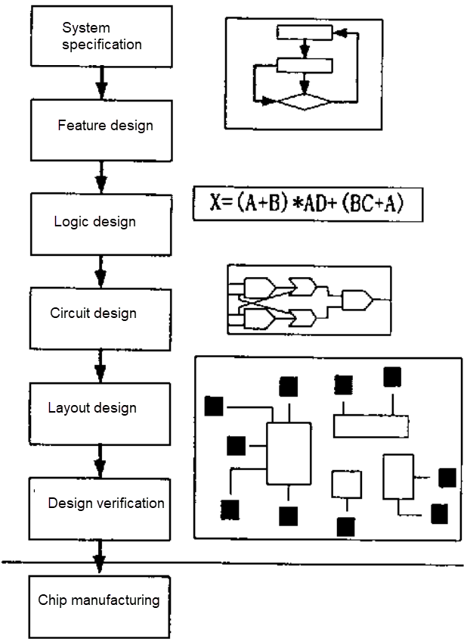

Figure 3.1 IC design flow

## 3.2.3 Low-power design technology

In the Ic design, power consumption has been the same as the area, speed, as a measure of the merits of the design indicators.

We know that the design of the power consumption can be divided into flip power consumption, short circuit power consumption, static power consumption in several parts. Table 3.1

Lists the proportion of rollover power consumption in some example circuits.

Table 3.1 Percentage of power consumption in different circuits

|  |  |  |
| --- | --- | --- |
| Circuit type | the power consumption in the proportion of total power consumption,% | |
| Multiplier | 86.9 |
| Adder | 84.9 |
| Floating point processing unit | 75.2 |
| Digital signal processor | 73.9 |
| Small SRAM | 54.4 |
| Microcontrollers | 46.8 |
| Large SRAM | 34.8 |
| DRAM | 18.9 |

In different circuits, the proportion of various types of power consumption is different, so the focus of low-power design is not

with. As can be seen from Table 3.1, in the operation of the circuit, the switching power consumption accounted for the vast majority, therefore, the power consumption of such circuits

Should focus on reducing switching power consumption; for DRAM memory, leakage power accounted for the majority, so to focus on

In reducing the leakage power and so on.

For different power types, with different low-power design methods.

For dynamic power consumption, you can reduce the physical capacitance, operating voltage, frequency, flip probability to proceed.

For static power consumption, you can increase the threshold, reduce the gate current to proceed.

Low power design runs through the entire Ic design process. At all design levels, there is a corresponding low-power design method.

(1) system-level low-power technology. Mainly to develop power solutions and clock solutions, select the algorithm to determine the structure,

To get the minimum power consumption.

A design can use a multi-power strategy, the system can be divided into different regions, each region is not

The same voltage. For example, a SOC design can be broadly divided into three parts: memory, embedded processor, other logic

Series. These three parts can use different voltages.

In addition, in the clock planning, but also take into account the power problem. The system clock has a significant effect on power consumption. drop

Low system operating frequency, can greatly reduce power consumption. The following scenario can be used: for critical paths, when used faster

Clock; for slower modules, use slower clocks. If the system does not currently work, you can switch the system clock to slow clock.

In many applications, all parts of the IC system are not required to operate at full speed. Can be based on application requirements, in the set

A variety of modules are used. For example, it can be divided into normal mode and power saving mode. In power saving mode, some will not be needed

The module to work on the clock / power off. In the portable design of this program is very common.

(2) circuit-level power consumption technology. In a system, the memory and I / O circuit power consumption accounted for a large proportion. By

So, I / O circuit and memory of the low power design is very important research content. This is a circuit-level low-power design

content.

(3) in the layout design, also need to consider the power problem. For the more flip point, the use of parasitic capacitance is smaller

Of the wiring layer. In the latest EDA tool, you can use power as an optimization target to generate a clock tree.

(4) the choice of production process will also affect power consumption. The same design, using CMOS or BICMOS, its power consumption is

Different. Moreover, the use of advanced production process, will improve the system integration, significantly reduce power consumption. But at the same time

Will increase the cost, so the choice of technology needs to compromise.

Table 3.2 lists the low-power design methods commonly used at different design levels.

Table 3.2 Low-power technologies at different design levels

|  |  |
| --- | --- |
| Design level | Low power design method |
| system | Try to choose a lower operating voltage: |
| Multi-power supply: a variety of working modes |
| Parallel processing to reduce the clock frequency |
| Circuit level | Change the circuit structure, reduce the signal swing; |
| White reverse biasing technique using transistor stacking effect |
| Layout level | Low Power Clock Tree Generation Technology |
| On the higher turn of the node, with low parasitic capacitance of the wiring layer of rice wiring |
| Process level | Using high dielectric constant material to reduce the gate leakage current |

## 3.2.4 Design the use of EDA tools

The design is used in the industry is more popular large-scale EDA software Cadence. It can almost complete the electronic design

All aspects of the design, including ASIC design, FPGA design and PCB board design. Especially in the simulation, circuit design,

Layout design and physical verification and so has an absolute advantage. The circuit design in this paper is Cadence

Virtuoso package; layout design using the layout package; physical validation using diva and Dracula.

The tool used in this paper is Cadence's Hspice simulator, which is used in the simulation environment.

Line simulation. Hspice is an excellent Spice software that plays an important role in simulation. Is the transistor level

Simulation of the industry standard, with a very high accuracy. At the same time, it also provides powerful behavioral simulation capabilities. in

With Hspice simulation of the behavior, the designer can directly use a variety of electronic design features and units, examples

Such as gain, bandwidth, offset voltage, capacitance, resistance, voltage control voltage source, voltage control current source. The flow of the circuit simulation using Hspice is shown in Figure 3.2 [17] [18].

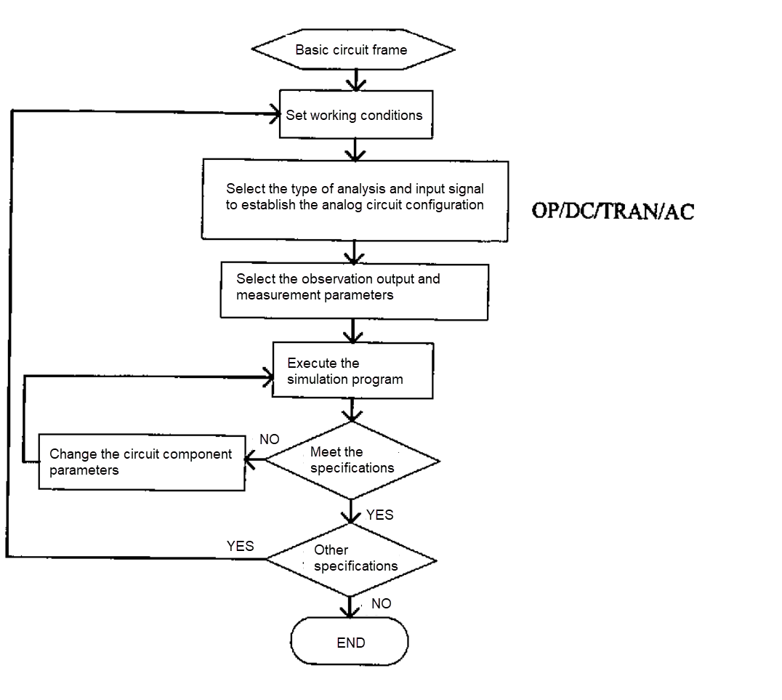

## 3.3 system chip circuit design

### 3.3.1 System structure design and circuit module division

Capacitive grid-type digital caliper special chip, the function of the process is: the chip generates a drive signal, sent to the capacitive sensing

Device, the sensor back to the modulation of the signal, through the chip to its demodulation, amplification, phase comparison and other columns of data

Processing, and thus converted into digital, and then by the British system operations and binary computing, and finally the data sent to the LCD into

Line display. In addition, it also has an automatic sleep mode, that is, when the device is stopped using more than 4 minutes, it will automatically

Into the sleep mode, which can play a role in reducing power consumption and extending battery life. Also has a key cleared mode,

It is possible to avoid the errors that occur when the conventional vernier caliper is manually aligned with the zero scale line. The chip can not only be used for calipers, but also

Can be applied to the production of l0 meters range range, high precision, low power consumption displacement measurement tool. Its internal structure design as shown

3.3.

According to the above description of the system chip function, the chip circuit can be divided into the following functions according to the function: clock

Generator, reference divider, power converter, excitation signal encoder, data acquisition and demodulation circuit, phase detection

Circuit (phase detector), arithmetic, controller, register, LCD display driver, serial interface and so on.

Due to the limited length of this article, in the following only on the chip power supply circuit, sampling and demodulation amplifier circuit and phase compensation

Road for details.

Capacitive gate sensor

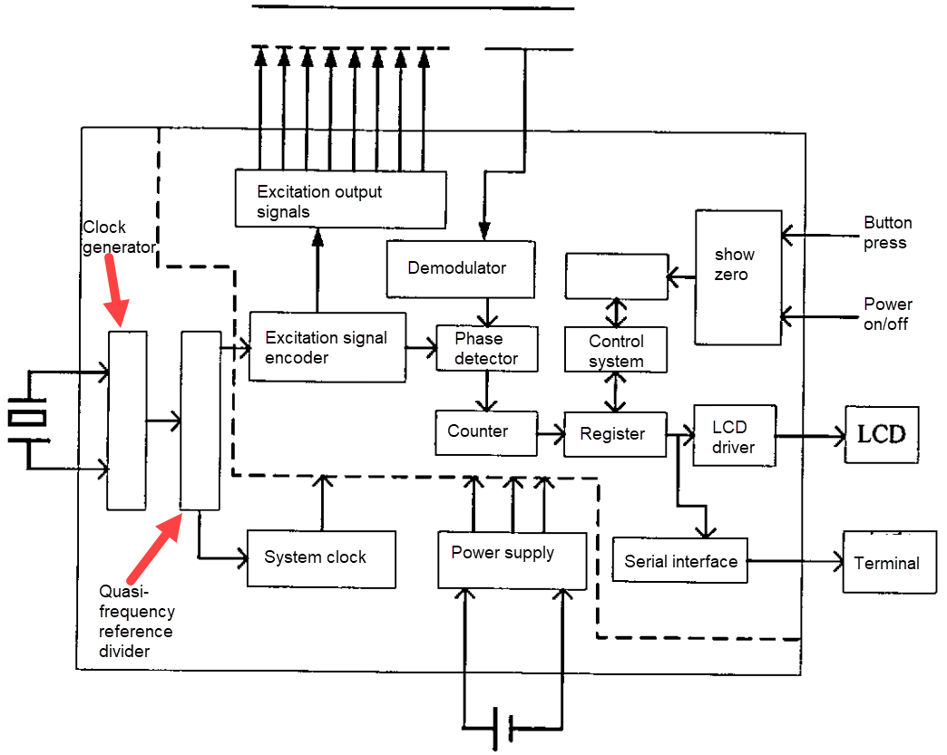

Figure 3.3 Block diagram of the overall structure of the system

### 3.3.2 Overall consideration of circuit design

The chip is a modular mixed-specific integrated circuit for low-power portable measurement systems, so in the design

When considering the following factors: the first ~, because the system is a battery-powered portable tools, designed to use

Low-voltage low-power technology; Second, the capacitive sensor on the signal is very weak, data collection, it is necessary to ensure that the foot

Enough of the gain to consider the acquisition accuracy; Third, the same chip integrates a digital circuit and analog circuits, to fully

Consider the mutual interference of digital circuits and analog circuits: Fourth, to drive the LCD screen, the voltage difference must be

2V or more, while the system by the battery-powered, the voltage is only 1.5V, so the need to design the on-chip power supply; Fifth, the core

The slice is integrated with a system that handles the amount of displacement, taking into account the displacement speed and chip processing speed and other issues.

### 3.2.3 Design of each circuit module

The following is the main module of the specific design and simulation to be introduced.

(1) data acquisition and demodulation circuit design and simulation

① functional requirements

From the analysis of the working principle of the capacitive sensor, it can be seen that the input signal of the capacitive sensor is the excitation signal of the 8-phase amplitude of the adjacent phase difference. Therefore, this paper first generates a set of clock pulses from the crystal oscillator.

185.185KHz, and then the clock pulse signal after the reference frequency to the excitation signal encoder, get a set of amplitude unchanged,

Wide and narrow according to the law of the periodic changes in the periodic rectangular wave sequence, the supply grid sensor as the excitation voltage of the launch electrode,

Cycle is 2500us, the waveform shown in Figure 3.4.

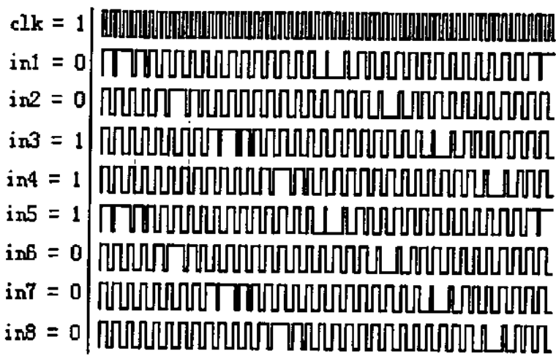

Figure 3.4: 8 excitation signal waveforms

The input signal is capacitively coupled by the capacitive sensor twice. Since the output signal is very weak, four special amplifiers are used in this paper to achieve the sampling and maintenance, amplification and demodulation of the sensor output signal. The working principle is shown in Figure 3.5:

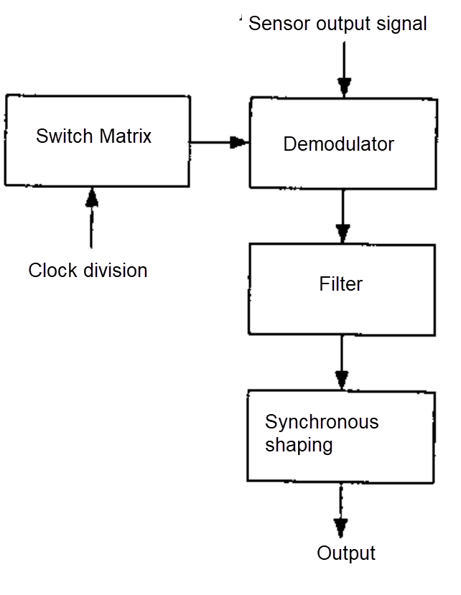

Figure 3.5 Block diagram of data acquisition and demodulation

The signal modulated by the sensor is sent to the demodulator for demodulation processing. The demodulator is controlled by the switch matrix. The switch is composed of four operational amplifiers with four times the clock cycle period. The demodulator under the control of the voltage switch, the output signal on the receiving electrode stored in the capacitor at both ends, and superposition, so that the amplitude of the output voltage increases nearly doubled, but also reflects the polarity of the output voltage. The period of the voltage after demodulation coincides with the period of the excitation voltage. Since the demodulated signal contains a high frequency component, the filtering process is performed so that the output voltage curve becomes smooth to improve the resolution of the phase. The filtered voltage is in the form of a sine wave. And then through the shaping of the output voltage into a square wave form. Thus easy to phase control.

② circuit design and simulation

In this paper, according to its functional requirements designed to the capacitive sensor output signal sampling and maintenance, amplification and demodulation

The circuit, circuit principle and control timing waveforms are shown in Figures 3.6 and 3.7:

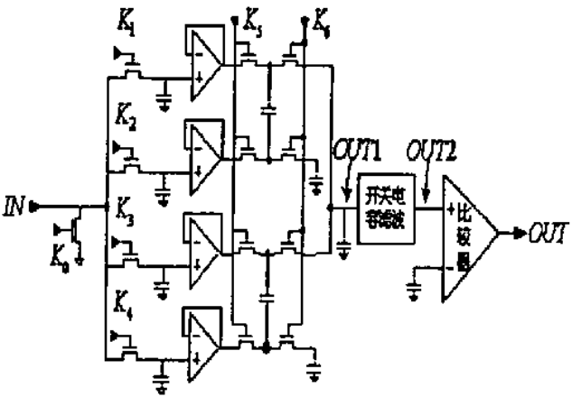

Figure 3.6 Data acquisition and demodulation circuit

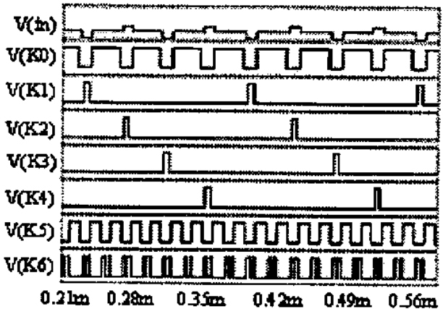

Figure 3.7 Control matrix for switch matrix and demodulator

The data acquisition and demodulation circuit is simulated by Hspice simulation software. The simulation waveform is not shown in Figure 3.8.

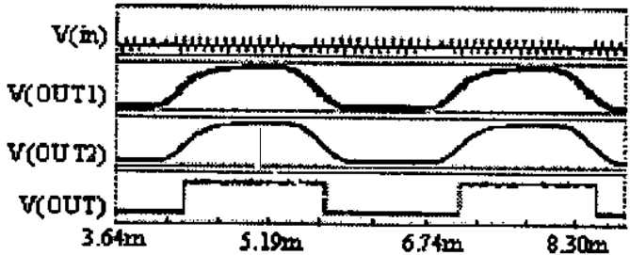

Figure: 3.8 demodulate the simulation waveform

Figure 3.8, the signal V (in) for the capacitive sensor output signal, you can see very weak, the signal V (out1) Is demodulated by the demodulator, amplified after the signal, similar to the sine wave, but contains a lot of high harmonics, the signal

V (OUT2) is the signal after switched-capacitor filter, is a smooth sine wave, the signal V (OUT), that is, solution

The final output signal of the converter is the square wave signal after synchronous shaping.

(2) charge pump circuit design and simulation

① functional requirements

With the continuous improvement of the level of technology, device features continue to reduce the size of the requirements of low power consumption more and more high,

For future CMOS very large scale integrated circuit design, the power supply voltage is less than 2V has become necessary. especially

For portable system-on-chip, in order to reduce costs, save energy, extend battery life, low power consumption is essential,

Thus a major design trend is to reduce the supply voltage. In the traditional digital CMOS ICs, the supply voltage is

Reduce the direct result of slowing down, the noise margin becomes smaller. And in analog switch control applications, less than 2V will not

normal work. So, to make the whole system to work properly, the different components of the system must work in different electricity

Source voltage. To solve this problem, the method is to use the charge pump circuit to pump the voltage to meet different requirements [19].

Charge pump circuit is a capacitor through the charge accumulation effect to produce higher than the power supply voltage or negative voltage circuit, is also a common DC-DC circuit. Usually the use of batteries as a power supply of the display (such as the LCD screen) are present

Life defects: the battery began to use, the voltage is reduced, affecting the use of results. In the circuit, use a boost type

Charge pump, will be able to reduce the voltage in a short period of time to stabilize the operating voltage. And many ADCs need to be negative

Voltage supply, then need to step-down charge pump. So the charge pump circuit can manage the use of battery power, extended

Battery life, improve efficiency, get more economical benefits. Charge pump is also suitable for LCD driver, smart card reader

Machine, USB 5V power supply, GSM mobile phone SIM interface power [20].

In this paper, because it is necessary to consider low-voltage low-power factor, but also to drive the LCD display, so the same time on-chip

In the two operating voltage that is 1.5V and 3V, for the digital part of the 1.5v power supply, and the analog part of the crystal in addition to mining

Powered by 3V. To this end, this paper designed the charge pump negative voltage generation circuit to pump the 1.5V negative voltage and the supply voltage is

The difference between 1.5V forms a 3.0V on-chip power supply.

② circuit design and simulation

In this paper, according to its functional requirements to design a negative charge pump charge circuit, the circuit shown in Figure 3.9. Simultaneously

The function of the circuit is verified by Hspice simulation software. The simulation waveform is shown in Figure 3.10.

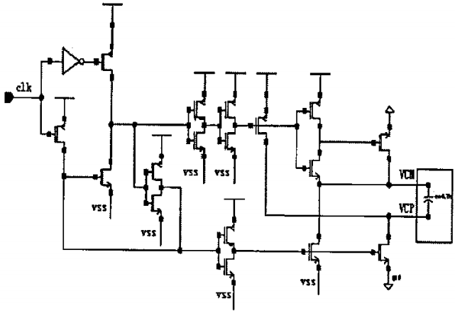

Figure 3.9 Charge pump negative voltage generation circuit

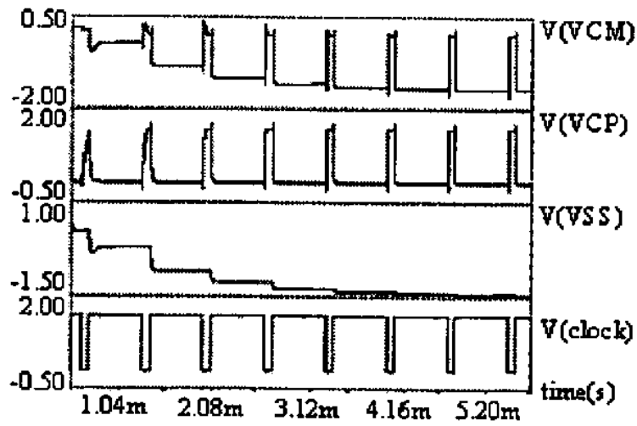

Figure 3.10: Negative voltage generator simulated waveforms

It can be seen from the simulation waveform of Figure 3.10 that the output voltage of the negative voltage charge pump circuit is finally stabilized to -1.5V, which achieves the expected design goal.

(3) design and simulation of phase detection circuit

① functional requirements

Phase detector is the phase comparator, its function is to detect the input signal and the reference signal between the phase deviation,

With the phase deviation to produce the control signal [2 ". In order to illustrate the function of the phase detector, this paper first introduces one of the simplest phase detector circuits, the OR-gate phase detector.

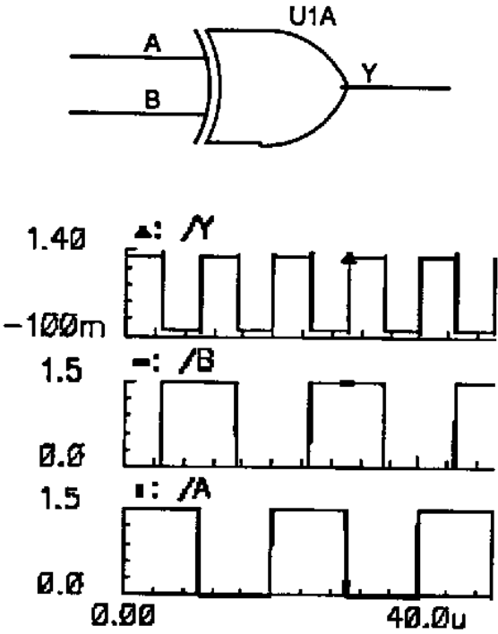

Figure 3.11 XOR gate phase detector and its simulation waveform

!!!!TRANSLATED TO PAGE 34, REST NOT TRANSLATED YET